Q : 1 What is Program ?
Ans : Program is defined as a set of instructions, that is used to perform specific task.

Q : 2 Write a simple “Hello World” program into two different programming languages of your choice. Compare the structure and syntax.
Ans : C Language :
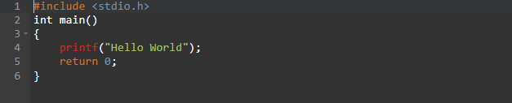

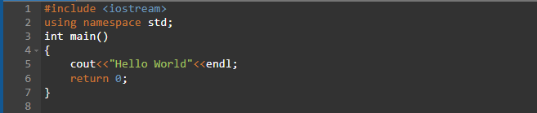
C++ Language :

- #include<stdio.h> and #include<iostream> is header library in C and C++ programming language respectively.
- printf() function and cout command is used to print text on console screen.

Q : 3 Explain in your own words what a program is and how it function.
Ans : A program is a set or group of instructions written by user to perform specific task in programming software.
Let’s take an example of C programming Language and see how it function. C Programming follow top-down approach.
i). Compilation
ii). Execution

Q : 4 What is Programming ?
Ans : Programming is the process of giving instructions to computer so it can perform specific tasks using mouse and keyboard.

Q : 5 What are the key steps involved in the programming process ?
Ans : Following steps are followed in programming process :
- Define the problem for which you want solution.
- Design the solution on paper
- Code the solution
- Test & Debug the program.
- Deploy the program.

Q : 6 Types of Programming Languages.
Ans : There are 4 types of programming Language :
1). Procedural Programming : ( C Programming Language ).
2). Object Oriented Programming : ( C++ Programming Language ).
3). Logical Programming : ( Prolog Programming Language ).
4). Functional Programming : ( Python Programming Language ).

Q : 7 What are difference between High-Level and Low-Level Programming Language?
Ans : High-Level Programming Language & Low-Level Programming Language:
- Low-Level Programming Language basically close to Machine as it written in form of CPU instruction.
Ex : Assembly and Machine code.
- High-Level Programming Language basically is closed to human, as it written if form of simple English language.
Ex: Python, C,C++, etc.

Q : 8 World Wide Web & How internet works ?
Ans : WWW is known as web. WWW is a collection of websites or web pages stored in web servers and connected to local computers through the internet. These websites contain text pages, digital images, audios, videos, etc. User can access the content of these sites from any part of the world over the internet using their devices such as computers, laptop and mobile etc.
A server is where websites are stored, and it works a lot like your computer’s hard drive. Once the request arrives, the server retrieves the website and sends the correct data back to your computer. One of the best features of the internet is the ability to communicate almost instantly with anyone in the world.
Ex : Email, Social Media

Q : 9 Research and create a diagram of how data is transmitted from a client to server over the internet.
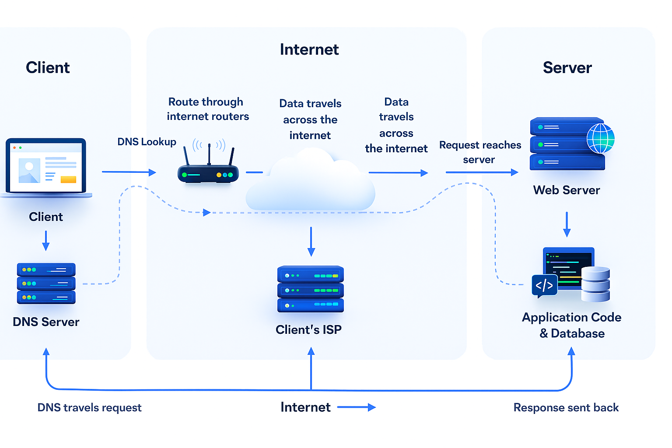
Ans :

Q : 10 Describe the roles of the client and server in web communication.
Ans : Client :
- Sending the request.
- Presenting the response.
- User Interaction.
- Ex : Web Browser on your laptop or cell phone.
- Doesn’t communicate directly with other clients.
- Needs to know the server’s address.
Server :
- Services requests from many client hosts.
- Accessing the database.
- Sending the Response.
- Security & Authentication.
- Ex : Web Server for the ww.example.com web site.
- Need a fixed, well-known address.

Q : 11 Network Layers on client and serve.
Ans :
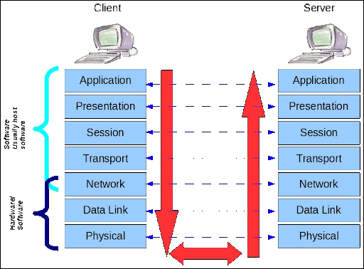

Q : 12 Design a simple HTTP client-server communication in any language.
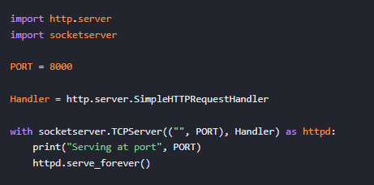
Ans : Server :

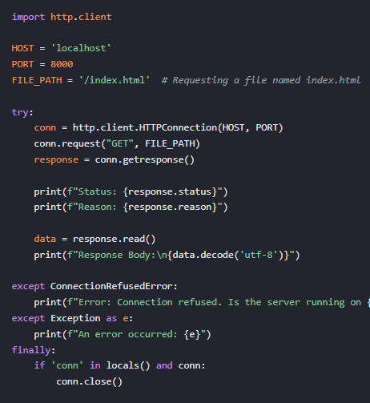
Client :

Q : 13 Explain the function of the TCP/IP models and its layers.
Ans : The TCP/IP model is the fundamental architecture that describe how data is transmitted across the internet. It defines how computers communicate, how data is package, addressed, sent, and received. It consists of 4 layers.
- Application Layer :
This layer provides networks services directly to the user or application. It defines how applications interact with the network.
- Transport Layer :
Responsible for end-to-end communication, reliability, and data flow control.
- Network Layer :
This layer handles routing, deciding the path that data packets take through the internet.
- Link Layer :
Responsible for physically transmitting data over the network.

Q : 14 Client and Servers :
Ans : Client :
Client is device used by the user. By using device user send requests to server and get response on user screen.
Ex : Browser, Mobile apps, Mobile phones.
Server :
Server gives the response on the basis of the client requests. Server is a collection of webpages and data in form of images, video, audio, etc.
Ex : Google’s server, Amazon server, Microsoft server etc.

Q : 15 Explain Client-Server Communication.
Ans : Client :
- Initiates a request to the server when interested.
- Ex : Web Browser on your laptop or cell phone.
- Client is “sometime on”.
- Doesn’t communicate directly with other clients.
- Needs to know the server’s address.
Server :
- Services requests from many client hosts.
- Ex : Web Server for the ww.example.com web site.
- Server is “always on”.
- Doesn’t initiate contract with the clients.
- Need a fixed, well-known address.

Q : 16 Types of Internet Connections.
Ans :
- Digital Subscriber Line (DSL)
- Cable Internet
- Fiber Optic
- Satellite Internet
- Wireless
- Broadband Over Power Lines (BPL)

Q : 17 Research different types of Internet connection (e.g., broadband, fiber, satellite) and list their pros and cons.
Ans : 1). Broadband
-> Pros :
i. Widely available
ii. Affordable
iii. Can use internet + landline at the same time.
-> Cons :
i. Slower compare to fiber
ii. Speed decreases if you’re far from the telephone exchange.
iii. Not ideal for heavy tasks.

2). Fiber Optic Internet
-> Pros :
i. Extremely high speeds.
ii. Very reliable.
iii. Suitable for heavy tasks
-> Cons :
i. More expensive
ii. Not available everywhere
iii. Installation takes time.

3). Satellite Internet.
-> Pros :
i. Available almost everywhere
ii. No cables required.
iii. Good for basics browsing, email.
-> Cons :
i. Very high latency.
ii. Weather affects connection.
iii. Expensive plans and equipment.

4). Mobile Internet.
-> Pros :
i. Portable
ii. 5G offers fibers-like speeds
iii. No installation needed.
-> Cons :
i. Dependent on network coverage.
ii. Data Limits can be expensive.
iii. Signal weeks indoors sometimes

Q : 18 How does broadband differ from fiber-topic internet?
Ans : Broadband :
- Uses copper telephones wires.
- Same Wires used for landline phones
- Slow to medium speed (5 Mbps – 50Mbps)
- High Latency
- Almost available everywhere.
- Cheaper
- Old Technology

Fiber Optics :
- Uses thin glass fibers.
- Data travels as light signals.
- 100 Mbps – 1Gbps or more.
- Very low latency.
- Note affected by distance or weather.
- Slightly Expensive
- New Technology

Q : 19 Protocols.
Ans : A network protocols is a group of rules accompanied by the network.
- Networks protocols will be formalized requirements and plans composed of rules, procedures, and types that describe communication among a couple of devices over the networks.
- The protocols can be described as an approach to rules that enable a couple of entities of a communication program to transfer information through any type of variety of physical medium.
- The Protocols identifies the rules, syntax, semantics and synchronization of communication and feasible error managing methods.

Q: 20 Simulate HTTP and FTP request using command line tools (e.g., curl).
Ans: Simulating HTTP Requests Using curl.
- GET Request:
curl https://example.com

- POST Request:
curl -X POST -d "username=mohit&password=1234" http://example.com/login

Simulating FTP Requests Using curl.
- GET Request:
curl ftp://ftp.example.com/myfile.txt --user username:password

- PUT Request:
curl -T report.pdf ftp://ftp.example.com/uploads/ --user username:password

Q : 21 What are the difference between HTTP and HTTPS protocols?
Ans : HTTP :
- HyperText Transfer Protocol
- Not Secure
- Data sent is plain text
- Hacker can intercept data.
- Ex : http://www.google.com
- No need for SSL certificate

HTTPS :
- HyperText Transfer Protocol Secure
- Secure
- Data is encrypted using SSL or TLS
- Data becomes unreadable to outsiders.
- Ex : https://www.google.com
- Requires SSL certificate

Q : 22 Application Security
Ans : Application security refers to security precautions used at the application level to prevent the theft or hijacking of data or code within the application.
It includes security concerns made during application development and design, as well as methods and procedures for protecting applications once they’ve been deployed.

Q : 23 Identify and explain three common application security vulnerability. Suggest possible solution.
Ans : SQL Injection : When an attacker insert malicious SQL code into input field to access or modify the database.
- Use Prepared Statements/ Parameterized Queries.
- Validate and Sanitize user Input.
- Apply least-privilege access to database users.
Cross-Site Scripting : When an attacker injects malicious JavaScript into a website, which runs in the victim’s browser.
- Escape all user-generated content.
- Sanitize HTML input.
- Validate input on both client & Server.
Cross-Site Request Forgery : An attacker tricks a logged-in user into performing actions they didn’t intend transfer, changing password.
- Require re-authentication for sensitive actions.
- Block third-part requests

Q : 24 What is the role of encryption in securing applications?
Ans : Encryption is one of the most important techniques used to secure data in applications. Its main purpose is to protect sensitive information so that even if someone intercepts it, they cannot read or misuse it.
- Protect Data Confidentiality
- Secures Data During Transmission
- Secure Data While Stored
- Prevents Unauthorized Access
- Protect Passwords
- Ensure Data Integrity

Q : 25 Software Application and its types.
Ans : It is a type of software application that helps in the automation of the task based on the User input.
- It can be performed single or multiple tasks at the same period of time.
- There are the different application which helps us in our daily life to process out instructions based on certain rules and regulation.
- Different high-level languages are used to build application software.
Types Application Software :
1). Application Software
2). System Software
3). Driver Software
4). Middleware
5). Programming Software

Q : 26 Identify and classify 5 applications you use daily as either System software or Application software.
Ans : System Software :
- Windows
- MacOS
- Linux
- Ubuntu
- iOS
Application Software :
- Microsoft Word
- Google Chrome
- Spotify
- Instagram
- VLC Media Player.
Q : 27 What is the difference between System software and Application software?
Ans : System Software :
- Controls and Manages the hardware of the computer.
- Provide a platform for application to run.
- OS, Device drivers, utility programs, etc.
- Works in background.
- Comes pre-installed with the device.
Application Software :
- Helps the users perform specific tasks or activities.
- MS Office, Whatsapp, Instagram etc.
- Works at the user level.
- Installed by the user as needed.
- Easy to install/Uninstall.

Q : 28 Software Architecture.
Ans : Software Architecture is blueprint of building software. It shows the overall structure of the software, the collection of components in it, and how they interact with another while hiding the implementation.
This helps the software development team to clearly communicate how the software is going to be built as per the requirement of customer.

Q : 29 Design a basic three-tier software architecture diagram for web application.
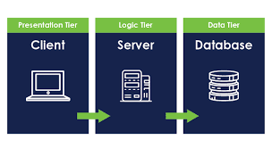
Ans :

Q : 30 What is the significance of modularity in software architecture?
Ans : Modularity means breaking a large software system into small, independent, manageable parts called modules.
- Easier to understand.
- Easier to maintain
- Reusability
- Independent Development
- Better Scalability
- Reduce coupling & Increase Flexibility.

Q : 31 Layers in Software Architecture.
Ans : There are 5 Layers :
- Presentation Layers
- Application Layers
- Business Layer
- Persistence Layer
- Database Layer

Q : 32 Create a case study on functionality of the presentation, business logic, and database layers of a given software system.
Ans : “Online Shopping System”
- Presentation Layer ( UI Layers ):
The Presentation Layer is responsible for everything the user sees and interacts with. It provides the interface through which users access the system.
Key Responsibilities :
1). Display product listing, product details, cart, and order summary.
2). Handle user inputs such as clicks, searches, and form submissions.
3). Send user requests to the business logic layer.
4). Show responses from the backend.
- Business Logic Layer (Application Layer):
This layer contains the core logic, rules, and decision – making mechanism of the application. It acts as a bridge between the Presentation layer and Data Access Layer.
Key Responsibilities :
1). Validate user inputs.
2). Apply business rules.
3). Manage workflows such as a user registration, payment processing, or order creation.
4). Communicate with the database through the Data Access Layer.
5). Ensure security.

- Data Access Layer ( Database Layer ):
The Data Access layer is responsible for all interaction with the database it stores, retrieves, updates, and delete data.
Key Responsibilities :
1). Execute SQL queries or ORM operations.
2). Manage product data, user accounts, order, inventory, and payments.
3). Maintain data integrity and security.
4). Return data integrity and security.

Q : 33 Why layers are important in Software Architecture?
Ans :
- Separation of Concerns
- Easier to Maintain and Update
- Reusability
- Better Testing
- Improved Scalability
- Enhanced Security
- Flexibility and Modularity
- Team Collaboration

Q : 34 Software Environment.
Ans :
- Analysis & Design Environment
- The Development Environment
- The Common build Environment
- The Testing Environment
- The Production Environment

Q : 35 Explore different types of software environment.
Ans : 1). Analysis & Design Environment :
The Analysis & Design environment is aligned to the planning and analysis phases of the SDLC. In this environment, the main processes that take place include carrying out an in-depth examination of the current system and proposed system. The system architecture is also defined and includes developing the design of the hardware, software and network requirement for the system. With this environment, system and business analysts work closely with software engineers.
2). The Development Environment :
The development environment can also by physical space where development takes place and where software engineer interact. Another example of the development is the integrated development environment. The IDE provides a platform where tools and development processes are coordinated in order to provide software engineers a convenient way of accessing the resources they require during the development process.
3). The Common Build Environment :
The common build environment is closely aligned to the development phase of the SDLC. In this environment, software engineers merge the work done in the development environment. Within this environment, software engineers build systems. These are used to automate the process of software compilation.
4). The Testing Environment :
The test environment is where testing team evaluate the application/quality programs. This also allows computer programmers to find out an solve any defects that may interfere with application smooth operation or degrade the user experience.
5). The Production Environment :
When the end-user use a web/mobile application, the program is operating on a production server. It’s been created in the production environment.

Q:36). Explain the importance of a development environment in software production.
Ans:
- Safe Testing without Affecting Real users
- Faster Development and Debugging
- Versional Control and Backup
- Consistency for the whole Team.
- Simulate the production Environment
- Helps in Continuous Integration & Testing
- Safe Space for Experimenting
- Better collaboration.

Q:37 What is the Difference between source and machine code?
Ans: Source Code:
Source code is the human-readable code written by programmers in programming languages likes:
Written using alphabets, numbers, symbols. Easy for humans to read and understand. Not understandable by the computer directly. Need compiler or interpreter.
- C
- Java
- JavaScript
- Python

Machine Code:
Machine code is the computer-readable code in binary (0’s and 1’s):
This is the only language your CPU understands. Not readable by humans. Written in binary or low-level instructions. Generated automatically from source code.

Q:38 Github and Introduction.
Ans: Github is a web-based platform used for version control, collaboration, and storing code.

Q:39 What are the benefits of using Github for Student.
Ans: Store code online
- Version Control
- Collaboration
- Open-Source Projects
- Project Management Tools
- Showcase your portfolio
- Automation & Deployment

Q:40 Types of Software.
Ans: Types of Software are:
- Application Software
- System Software
- Driver Software
- Middleware
- Programming Software

Q:41 Create a list of software you use regularly and classify them into the following categories: System, Application, Utility Software.
Ans: System Software:
- Windows
- macOS
- iOS
- Linux
Application Software:
- Google Chrome
- Microsoft Word
- YouTube App
- Zooms
Utility Software:
- Antivirus
- WinRAR
- CCleaner
- Disk Cleanup

Q:42 What are the difference between open-source and proprietary software.
Ans: Open-Source Software:
- Source code is public and freely available.
- Anyone can view, modify, and redistribute code
- Highly customizable because code is open.
- Community driven support.
Proprietary Software:
- Source code is closed and owned by company or individual.
- User cannot view and modify the internal code.
- Usually paid
- Only company can modify the software.
- Regular updates, but controlled by the vendor.

Q:43 Follow a GIT tutorial to practice cloning, branching, and merging repositories.
Ans: Cloning: git clone https://github.com/octocat/Hello-World.git
Branching: git branch feature-login
Merging: git merge feature-login

Q:44 How does GIT improve collaboration in a software development team?
Ans:
- Allows multiple people to Work at the same time.
- Prevent code conflicts
- Track every change in Project.
- Branching and Merging Makes team work easy.

Q:45 Application Software.
Ans: The most common type of software, application software is a computer software package that perform a specific function for a user, or in some case, for another application.
- An application can be self-contained, or it can be group of programs that run the application for the user.

Q:46 Write a report on the various types of application software and how they improve productivity.
Ans: Mirosoft Office:
- Speed up documentation creation.
- Automate calculations
- Allows easy editing and collaborations.
- Improves accuracy and organization.
Gmail, WhatsApp (Communicating Software):
- Enable fast communication
- Supports remote teamwork
- Reduces travel time and cost
- Helps in real-time decision-making

Web Browser:
- Quick access to online information
- Supports cloud-based tools
- Helps research and communication

Q:47 What is the role of application software in business?
Ans: Roles are:
- Automation of Business.
- Improved Communication
- Efficient data Management
- Enhanced Decision-Making
- Financial Management
- Customer Relationship Management
- Market & Advertising

Q:48 Software Development Process.
Ans: 1). Requirement Gathering
2). Analysis
3). Designing
4). Implementation
5). Testing & Debugging
6). Deployment

Q:49 Create a flowchart representing the Software Development Life Cycle (SDLC).
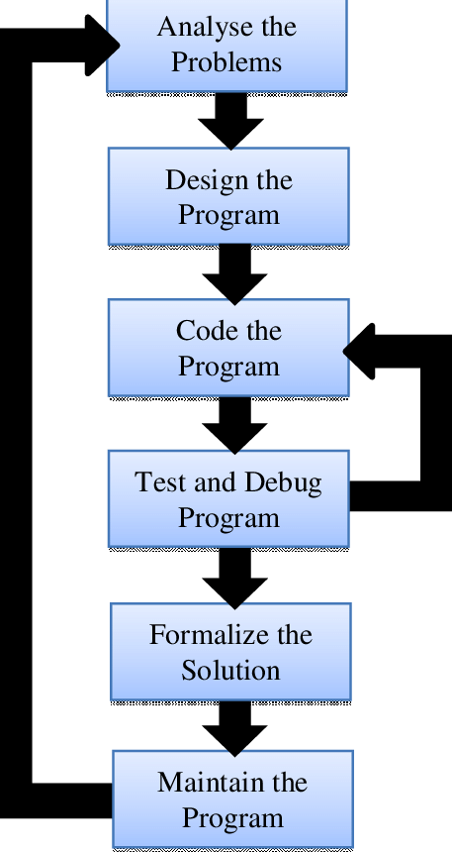
Ans:
Q:50 What are the main stages of the software development process.
Ans: 1). Requirement Gathering
2). Analysis
3). Designing
4). Implementation
5). Testing & Debugging
6). Deployment

Q:51 Software Requirement.
Ans: Software Requirement are the needs, expectations, and conditions that a software system must satisfy to work correctly for users, customer, and the business.

Q:52 Write a requirement specification for a simple library management system.
Ans: 1). LMS: Library Management System
2). User: Member using the library
3). Librarian: Administrator of the system
4). Issue: Borrow a book
5). Return: Give back a borrowed book

Q:53 Why is the requirement analysis phase critical in software development?
Ans: 1). It defined the project Scope
2). It Prevent Miscommunication
3). It saves Time and Cost
4). It Helps in Better System Design
5). It Identify Risks Early
6). It Ensure User Satisfaction
7). It forms the Basis for Testing

Q:54 Software Analysis.
Ans: Software Analysis is the phase in the Software Development Life Cycle where the development team studies, understands, and defines the requirements of system in detail.

Q:55 Perform a functional Analysis for an Online Shopping System.
Ans: 1). Guest User
2). Registered Customer
3). Admin
4). Seller
5). Payment Gateway
6). Shipping Provider
7). Search/Recommendation Engine

Q:56 What is the role of software analysis in the development process?
Ans: 1). Understand User Needs
2). Defining what the system should do.
3). Removing the Ambiguities
4). Improving System Design
5). Reducing Development Cost and Time
6). Ensuring Feasibility
7). Foundation for Documentation
8). Supports Testing

Q:57 System Design
Ans: System Design is the process of planning and creating the architecture of a software system. It focuses on how the system will work, how different components will interact, and how the requirement will be implemented in technical way.

Q:58 Design a basic system architecture for a food delivery system.
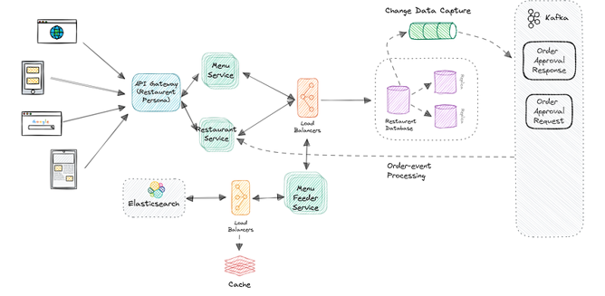
Ans:

Q:59 What are the key elements of system design?
Ans: 1). Architecture Design
2). Data Design
3). Interface Design
4). Components Design
5). Security Design
6). Scalability Design
7). Performance Design
8). Network Design
9). Error Handling & Logging
10). Technology Stack Selection

Q:60 Software Testing
Ans: Software Testing is the process of checking whether a software application works correctly, meets the requirements, and is free of defects. It ensures that the software is reliable, secure, fast and user-friendly before it is delivered.

Q:61 Why is software testing important?
Ans: 1). Ensure the software works correctly
2). Improves software quality
3). Saves time and cost
4). Ensure security
5). Builds user trust and satisfaction
6). Ensure Compatibility
7). Meets Requirements
8). Prevents failures after release.

Q:62 Maintenance.
Ans: Software Maintenance is the process of modifying, improving, and updating software after it has been delivered and deployed.

Q:63 Document a real-world case where a software application required critical maintenance.
Ans: WhatsApp Global Outage (2022)
1). Background:
Whatsapp is a cloud-based messaging app with billions of users.
2). Nature of the problem:
During the outage:
- User could not send or receive messages.
- Group chats stopped working
- Message remained stuck
3). Maintenance Steps Performed:
- Issue Identification
- Rollback the Faulty Update
- Restart Server Clusters
4). Verify System Stability:
- Messaging sending
- Group Chats
- Video/Voice calls

Q:64 What types of software maintenance are there?
Ans: 1). Corrective Maintenance
2). Adaptive Maintenance
3). Perfective Maintenance
4). Preventive Maintenance

Q:65 Development
Ans: Software Development is the complete process of creating a software application.
- Understanding what users need
- Planning the system
- Designing how it will work
- Writing the code
- Testing it to remove bugs
- Releasing the software
- Updating and improving it over time

Q:66 What are the key difference between web and desktop application.
Ans: Web Application:
- Run inside a web browser
- Accessed using a URL
- No Installation required
Desktop Application:
- Installed directly on a computer.
- Does not need a browser.

Q:67 Web Application.
Ans: A web application (web app) is an interactive application that uses a web browser as the client interface.
You do not have to install anything — you simply open a browser (Chrome, Firefox, etc.) and access it through a URL.

Q:68 What are the advantages of using web application over desktop applications?
Ans: 1). No installation Required
2). Accessible from anywhere
3). Automatic Updates
4). Easy Collaboration
5). Platform Independent
6). Lower Hardware Requirement
7). Centralized Data Storage
8). Cross-Device Responsiveness

Q: 69. Designing
Ans: Designing is the stage in software development where we plan how the software will look, work, and be built before writing the code.

Q: 70. What roles does UI/UX design play in application development.
Ans: 1). Creates a Good First Impression
2). Makes the applications Easy to Use
3). Improves User Satisfaction
4). Increases Efficiency & Productivity
5). Reduce Development Cost
6). Enhance Communication with Developers
7). Supports Usability Testing
8). Boosts Accessibility
9). Increases Engagement & Conversions

Q: 71. Mobile Applications.
Ans: Mobile applications (or mobile apps) are software programs designed to run on mobile devices such as smartphones, tablets, and smartwatches.
They are installed through app stores like Google Play Store, Apple App Store, or Windows Store.

Q: 72. What are the difference between native and hybrid mobile apps.
Ans: Natives Apps:
- Apps built specially for one platform
- Java/Kotlin programming language is used.
- Cost of Development is high
- Development time is longer.
- More efforts require for maintenance.
- Installed from play stores.
Hybrid Apps:
- Apps built using web technologies (HTML, CSS, JS) and wrapped to run on mobile
- Performance is moderately.
- Also installed like native apps
- Maintenance is easier.
- Instagram, Gmail etc

Q: 73. DFD (Data Flow Diagram).
Ans: A Data Flow Diagram (DFD) is a visual tool used in software engineering to show how data moves inside a system.
It focuses on:
- Where data comes from
- Where it goes
- How it is processed
- Where it gets stored

Q: 74. Create a DFD for a hospital management system.
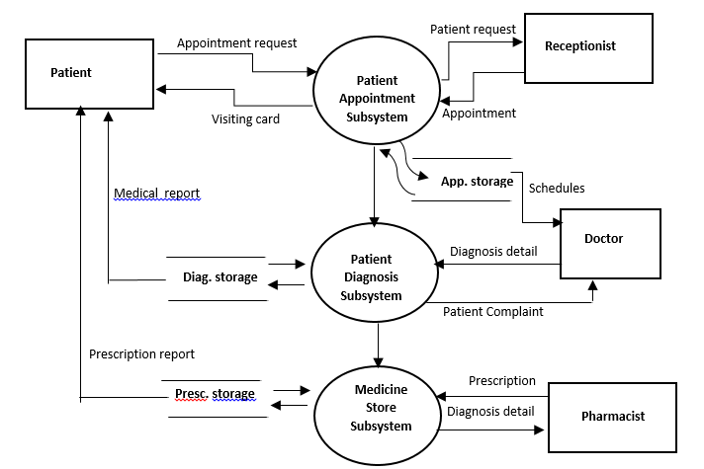
Ans:

Q: 75. What is the significance of DFD in system analysis?
Ans: 1). Helps understand the system Easily
2). Improves Communication
3). Helps Identify problems in the system
4). Helps in creating better system Architecture
5). Supports Requirement Analysis
6). Helps in Documentation
7). Foundation for database and Process Design

Q: 76. Desktop Application
Ans: A desktop application is a type of software that is installed and runs directly on a computer (Windows, macOS, or Linux), rather than through a web browser.
A desktop application is a program that runs locally on a personal computer.
It does not require the internet to function (unless features depend on it).
Example:
- Microsoft Word
- VLC Media Player
- Adobe Photoshop
- VS Code
- Notepad
- Calculator

Q: 77. What are the pros and cons of desktop applications compared to web applications?
Ans: Pros:
- Better Performance
- Work without Internet
- High Security
- Full Use of System Resource
- Richer Feature
Cons:
- Installation needed
- Platform-dependent
- Storage Consumption
- Updates are not Automatic
- Limited Accessibility

Q: 78. Flow Chart
Ans: A flowchart is a visual diagram that shows the step-by-step flow of a process, using symbols like boxes, arrows, diamonds, and ovals. It helps you understand how a system, program, or workflow operates.

Q: 79. Draw a flowchart representing the logic of a basic online registration system.
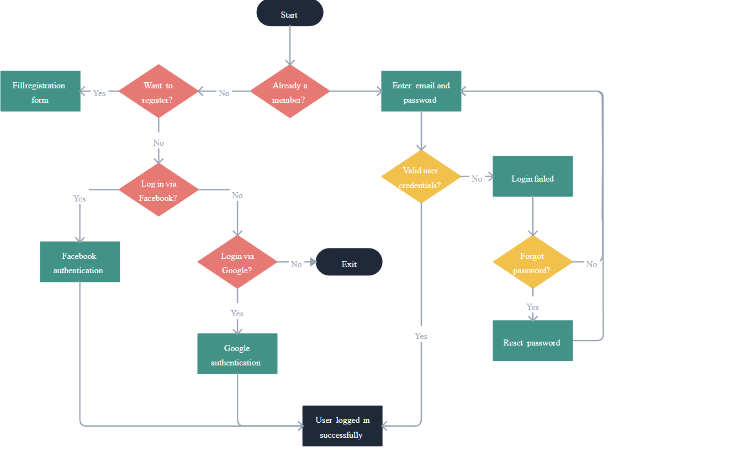
Ans:

Q: 80. How do flowcharts help in programming and system design?
Ans: Flowcharts are one of the most important tools used in programming and system design, especially when planning, understanding, and communicating how a system or program works.
1). They Make Logic Easy to Understand
2). They Help in Planning Programs
3). Easier Debugging and Problem Solving
4). Useful for System Design
5). Documentation Purpose
6). Improve Team Communication
7). Helps in Decision Making

